Chapter-I

**INTRODUCTION**

* 1. **OBJECTIVE:**

The main objectives of Traffitizer are to reduce risk to patient’s life, when an ambulance is struck in traffic, an intelligent traffic management system that can clear the traffic on the lane where the ambulance is present and an automatic conversion of signals in other lanes to avoid traffic collision.

* 1. **PROBLEM STATEMENT:**

During rush hours, emergency vehicles like Ambulances, Police cars and Fire Brigade trucks get stuck in jams. Due to this, these emergency vehicles are not able to reach their destinations in time, resulting into a loss of human lives. Traffic congestion is a major problem in cities of developing Countries like India. Growth in urban population and the middle-class segment consume vehicles to the rising number of vehicles in the cities. Congestion on roads eventually results in slow moving traffic, which increases the time of travel, thus be notable as one of the major issues in metropolitan cities. Emergency vehicles like ambulance and fire trucks need to reach their destinations at the earliest. If they spend a lot of time in traffic jams, valued lives of many people may be in danger. Here the image sequences from a camera are analyzed using various edge detection and object counting methods to obtain the most efficient technique. Then, the number of vehicles at the intersection is evaluated and traffic is efficiently managed. The traffic signal indication continuously glows to green as long as the emergency vehicle is waiting at the traffic lane.

* 1. **EXISTING SYSTEM:**

The current traffic control system (TCS) in the metro cities of India is inefficient due to randomness in the traffic density pattern throughout the day. The traffic signal timers have a fixed time period to switch traffic between different directions. Due to this, the vehicles have to wait for a long-time span even if the traffic density is very less. If the traffic signal timer (TST) can be programmed to be manipulated with the continuously varying traffic density, the problem of traffic congestion can be reduced to a significantly lower level. At present, the traffic control systems in India, lack intelligence and act as an open-loop control system, with no feedback or sensing network. The objective is to design an intelligent traffic signal control system algorithm with the use of sensing devices and image processing systems.

Traffic signals are vital to helping vehicles and pedestrians safely travel. They increase the efficiency and order of traffic to reduce the number of accidents.  One of the primary disadvantages of traffic signals is that they lead to an increase in rear-end vehicle collisions. Rear-end vehicle collisions occur more frequently when a driver abruptly stops at a yellow or red light, causing a distracted driver behind him to ram into the rear of his car.

* + 1. **DRAWBACKS:**
* While many people realize that traffic signals can reduce the number of angle collisions at an intersection, few realize that signals can also cause an increase other types of accidents. For example, it has been well documented that other types of accidents, notably rear-end collisions, usually increase when a signal is installed.
* Traffic signals should not be considered a "cure-all" for traffic congestion, and the primary goal of all traffic engineers is to attain the safest and most efficient traffic flow feasible.
* In addition to an increase in accident frequency, unjustified traffic signals can also cause excessive delays, disobedience of signals and diversion of traffic to inadequate alternate routes.
* There are many other disadvantages of current Traffic system such as excess of traffic delays, which in turn results in delay of emergency vehicles such as Ambulance and fire brigade, leading to loss of lives and property. It can also lead to aggressive and impatient driving.
  1. **PROPOSED SYSTEM:**

With the growth in urbanization, industrialization and population, there has been a tremendous growth of traffic. One of the adverse effects of traffic jams are faced by emergency vehicles like ambulance, fire brigades, etc. this problem of ambulance getting stuck in traffic jam can be addressed by ensuring that the lane in which the ambulance is travelling is cleared. This can be done using the proposed model.

Automatic traffic monitoring and surveillance are important for road usage and management. The project focuses on the severe impact caused by traffic congestion on the emergency vehicle transportation system. In places such as India and Thailand where the road width and length prove to be impossible to create a separate lane for emergency vehicles, it is difficult for ambulances to navigate through the traffic.

In the proposed system, the system will detect vehicle through images instead of using electronic sensors embedded in the pavement. A camera will be installed within certain distances from the traffic light it will capture the image sequences. Setting image of an ambulance as reference image, the captured images are sequentially matched using image matching.

The model is trained such that whenever an ambulance enters into the range of sensors then it captures the image and compares with the reference image. If it matches with reference image then the signal will be controlled and cleared, so as to give a clear way to pass the ambulance by changing the traffic signal from red to green for that particular lane in which the ambulance is detected. It helps to save the lives of human being by providing clear way to the ambulance. This process repeats at every traffic signal in the ambulance’s way till it reaches the nearby hospital on time and hence the lives are saved.

**1.4.1 ADVANTAGES:**

* Priority given to emergency vehicles.
* Traffic atomization.

Chapter-II

**SYSTEM ANALYSIS**

* 1. **LITERATURE SURVEY:**

Literature survey is a prerequisite for any project and it helps developing new concepts for implementing of the project. To carry out the project work in a phased manner it is necessary to conduct literature survey. A project requires a good insight about the basic concepts and understanding. To nourish these requirements references have been made to many textbooks.

Ayush Kr. Mittal and Deepika Bhandari proposed,” A novel approach to implement Green Wave System and detection of stolen vehicles in February 2013”. During rush hours, emergency vehicles like Ambulances, Police cars and Fire Brigade trucks get stuck in jams. Due to this, these emergency vehicles are not able to reach their destinations in time, resulting into a loss of human lives. We have developed a system which is used to provide clearance to any emergency vehicle by turning all the red lights to green on the path of the emergency vehicle, hence providing a complete green wave to the desired vehicle. A 'green wave' is the synchronization of the green phase of traffic signals. With a 'green wave' setup, a vehicle passing through a green signal will continue to receive green signals as it travels down the road. Around the world, green waves are used to great effect. Often criminal or terrorist vehicles have to be identified. In addition to the green wave path, the system will track a stolen vehicle when it passes through a traffic light. In contrast to any traditional vehicle tracking system, in which the Global Positioning System (GPS) module requires battery power, our tracking system, installed inside the vehicle, does not require any power. The information regarding the vehicle has to be updated in the system database. So, it is an autonomous 2-tier system which will help in the identification of emergency vehicles or any other desired vehicle. It is a novel system which can be used to implement the concept of the green wave.

Suresh Sharma, A.Pithora, G.Guptha, M.Goel, and M.Sinha published, “A RFID System in April 2013”. Traffic congestion is a major problem in cities of developing Countries like India. Growth in urban population and the middle-class segment consume vehicles to the rising number of vehicles in the cities. Congestion on roads eventually results in slow moving traffic, which increases the time of travel, thus be notable as one of the major issues in metropolitan cities. Emergency vehicles like ambulance and fire trucks need to reach their destinations at the earliest. If they spend a lot of time in traffic jams, valued lives of many people may be in danger. Here the image sequences from a camera are analyzed using various edge detection and object counting methods to obtain the most efficient technique. Then, the number of vehicles at the intersection is evaluated and traffic is efficiently managed. The traffic signal indication continuously glows to green as long as the emergency vehicle is waiting at the traffic lane. After the vehicle crossed the junction, automatically the traffic signals follow the previous pattern generation of traffic signals. This can be implemented in LABVIEW.

Geetha.E, V.Viswanadha, Kavitha.Gproposed,”An Intelligent Auto Traffic Signal Control system in July 2014”. Traffic congestion is one of the major issues to be considered. Generally Vehicular traffic intersects at the junctions of the road and is controlled by the traffic signals. Traffic signals need a good coordination and control to ensure the smooth and safe flow of the vehicular traffic. During the rush hours, the traffic on the roads is at its peak. Also, there is a possibility for the emergency vehicles to stick in the traffic jam. Therefore; there is a need for the dynamic control of the traffic during rush hours. Hence, I propose a smart traffic signal controller. The proposed system tries to minimize the possibilities of traffic jams, caused by the traffic lights, to some extent by clearing the road with higher density of vehicles and also provides the clearance for the emergency vehicle if any. The system is based on the PIC 16F877A micro controller, IR sensors and Radio Frequency Identification (RFID) technology. The code for this project is compiled in high tech C compiler and the simulated with Proteus software.

Vismay Pandit, Jinesh Doshi, Dhruv Mehta, Ashay Mhatre and Abhilash Janardhan proposed, “Smart Traffic Control System using Image Processing in January– February 2014”. As the problem of urban traffic congestion spreads, there is a pressing need for the introduction of advanced technology and equipment to improve the state of-the-art of traffic control. Traffic problems nowadays are increasing because of the growing number of vehicles and the limited resources provided by current infrastructures. The simplest way for controlling a traffic light uses timer for each phase. Another way is to use electronic sensors in order to detect vehicles, and produce signal that cycles. We propose a system for controlling the traffic light by image processing. The system will detect vehicles through images instead of using electronic sensors embedded in the pavement. A camera will be installed alongside the traffic light. It will capture image sequences. Setting image of an empty road as reference image, the captured images are sequentially matched using image matching. For this purpose, edge detection has been carried out using Prewitt edge detection operator and according to percentage of matching traffic light durations can be controlled.

Departure point We as humans seem to have a low acceptance for large-scale accidents with large numbers of causalities. Conversely, accidents that occur every day and „only‟ take one or a few lives do not seem to bother us nearly as much. The Swedish National Board of Health and Welfare estimated that in 2010, 658 000 people in Sweden had visited an emergency health- care facility due to an injury (Socialstyrelsen, 2011a). Of these 658 000 injuries, 80% were classified as accidental events. The same year in Sweden, the number of deaths was 90 519, just above 5% of them (in total: 4659) on account of injuries (Socialstyrelsen, 2011b). For every event of death 22 persons were hospitalized (in total: 102 500), and an additional 119 treated in outpatient emergency care (in total: 555 700) (Socialstyrelsen, 2011a). There is no doubt that injuries and accidents are important health problems, and by adding time for convalescence and permanent disabilities due to an injury or an accident the problem increases further (Krug, Sharma & Lozano, 2000). Incidents occur every day and everywhere. Therefore, considerable gains may be achieved by studying them. More effective response at the incident site could result in both decreased societal costs and decreased mortality rates. Studies concerning everyday incidents mainly focus on three areas; evaluation, risk reducing, and technical equipment.

Studies evaluating everyday incidents mainly focus on one component of the incident, such as specific actors on the scene (e.g. Laskowski-Jones, 2002), stress levels of rescue workers (e.g. Gerber, Kilmann, Hartmann & Pulse, 2010; Kales, Tsimicalis, Zhang & Soteriades, 2009) or on single consequences such as post-trauma (e.g. Mayou, Ehlers & Hobbs, 2003; Robinaugh et al., 2011). The reduction of risk is often focused on risk management, risk assessment and risk communication, often with the aim of developing incident system models (e.g. Leveson, Allen & Storey, 2002; Shrivastava, Sonpar & Pazzaglia, 2009). Some prevention studies focus on incidents and everyday hazards. However, many of them are executed in areas of the world such as Africa (e.g. Bull-Kamanga et al., 2003).

Everyday hazards in these areas are different from those in Sweden, and they involve components, such as urban poverty, lack of infrastructure for providing water and the absence of human rights, that are not as extensive in the Swedish society. There is an extensive amount of studies on designing technical equipment to facilitate emergency response. However, most of the ones concerning everyday incidents focus on the use of mobile defibrillators in out-of-hospital care (e.g. Hallstrom et al., 2004; Weisfeldt et al., 2010). The research domain of everyday incidents has many gaps. Very few studies deal with the everyday occurrence of incidents (Danielsson, Johansson & Eliasson, 2010; Demarin et al., 2010), even less with actual response. These scientific gaps are particularly noticeable when it comes to studies of lay persons, lay response, volunteers (Pelinka, Thierbach, Reuter & Mauritz, 2004; Stenberg, Blondin & Andersson Granberg, 2010; Venema, Groothoff & Bierens, 2010), the collaboration between different rescue organizations (Elmqvist, Brunt, Fridlund & Ekenberg, 2010), and the collaboration between lay responders and rescue organizations (Danielsson, Johansson & Eliasson, 2010). According to Krug, Sharma and Lozano (2000), one reason why injuries are overlooked in the scientific research is due to the fact that they are seen as random and accidental. Another area lacking research is the study and definition of crises at the level between everyday incidents and disasters (Voss & Wagner, 2010).

These are events that are too big to be addressed as everyday incidents, yet too small to be defined as disasters. In a Swedish context, the need for research on this level of incidents (so-called small disasters) may be more acute than studies of large-scale events. Because research explicitly directed toward everyday emergency response is so sparse, much of the contents of this literature review will be gathered from the domain of large-scale crisis response. Quarentelli (2006) argues that there are both quantitative and qualitative differences between everyday incidents and disasters. However, even if there is – which we are not opposing, we argue that there may be lessons to learn from studies of the different phenomenon, and that these lessons can be beneficial to both traditions. Schraagen and van de Ven (2011) mention several issues often seen during large-scale crises. Temporary work groups typically lack common conceptions and may be unfamiliar of working together. This means that responsibilities are often unclear. Furthermore, private and public stakeholders must coordinate their activities, the public must be engaged and informed, system-handshake issues between agencies are common, information flow is often poor and actors may have a wide geographical distribution. Although most current research within this field is directed toward these large-scale, multi-agency activities, some researchers make the claim that many of the features of massive emergency response can also be found in the handling of everyday incidents. For example, Nemeth, Wears, Patel, Rosen and Cook (2011) describe regular ambulatory healthcare in terms of flexibility and unpredictability. Operators are constantly engaged in fluid, dynamic cognitive activities and sharp-end workers often have to take the management initiative.

Everyday incidents also occur in complex environments, meaning that systems for frequent emergency response also must allow responders to tackle variability. Quarentelli (2006) highlights four organizational differences between the everyday incidents and disasters, one of which concerns the sudden nature of disasters. This force rescue organizations, as well as other organizations, to „quickly relate to far more and unfamiliar converging entities‟ (Quarentelli, 2006, p.1). It could be argued that lay responders experience this when they encounter an incident site. A recent study on accident-site collaboration between Swedish agencies reveals many problems in coordination (Berlin & Carlström, 2011). Even for these seemingly routine activities, work is fraught with issues. Salasznyk and Lee (2006) argue that there is a direct relation between the efficiency and effectiveness of everyday incident response, such as the handling of traffic incidents, and response ability in the face of major emergencies. On a similar note, Nemeth et al. (2011) make the observation that crises are quite uncommon in the high-hazard industries normally associated with systems safety research. As a contrasting example, ambulatory healthcare deals with life-and-death situations on a daily basis. This means that everyday incident response can provide a wealth of data to inform the design of larger-scale emergency response systems. In relation to this, Landgren (2005) notes the comparatively low interest in small-scale emergencies, and makes the observation that such minor events can quickly develop into major crises if not treated correctly.

In risk accumulation it is important to conduct local based research to understand the processes and factors specific for different cities, counties etcetera (Bull-Kamanga et al., 2003). What may be defined as an everyday incident in one geographical area may be seen as a disaster in another. For example, in some areas of the world flooding occurs so often that they are seen as everyday incidents, while they in other areas of the world are seen as disasters. The continuous occurrence of these events makes communities adapt rather than take action or preventing them, or at least decrease their impact on the community (Bull- Karamanga et al., 2003). Voss and Wagner (2010) stress the importance of understanding the temporal and spatial framework of incidents. This is an important notion in research of the response phase of everyday incidents, which may lead to savings in lives, economy and time for individuals, organizations, communities and so on. This implies that there is a need for research in different areas and components in the response phase, and how they may differ between areas in Sweden, from big cities, to small cities, to rural areas. Kristiansen et al. (2010) points out the need for regional trauma systems that uses available resources due to all the rural areas in Scandinavia, something also noted by Andersson Granberg et al. (2010) and Stenberg, Blondin and Andersson Granberg (2010). Also, as noted by Andersson Granberg et al. (2010), Bull-Kamanga et al. (2003), McNeil and Quarantelli (2008), and Örtenwall (1999) incidents are different, and the geographical context where the incident occurs makes it necessary for the responder to use creativity and imagination. On the societal level this creativity may include other voluntary organizations already trained in rescue operations (see. Andersson Granberg et al., 2010; Stenberg, Blondin & Andersson Granberg, 2010). Kapucu, Tolga and Demiroz (2010) describe emergency management as a process with specific demands. Different stakeholders must integrate their efforts and ensure collaboration. This means that trust and mutual understandings must exist between agencies, something that in turn demands a well-functioning system for communication and information sharing. Because of the dynamic nature of crisis events, a response system must also allow its operators to be flexible and creative when circumstances change. Research on the relation between people and their supporting technological systems has turned coordination and collaboration in emergency response into growing areas of scientific interest (Ödlund 2010). Consequently, these concepts till be thoroughly investigated in the present review.

**PHASES OF EMERGENCY MANAGEMENT**:

Emergency management is commonly divided into different phases (Chen, Sharman, Rao & Upadhyaya, 2011). Preparation means getting ready for imaginable future incidents, developing systems, managing resources, developing scenarios and plans and engaging in realistic training. Mitigation concerns actions taken to reduce the chances of an accident occurring (e.g. through risk assessment) or early attempts to make the consequences of an accident as small as possible. The Response phase covers actions carried out during the emergency, where joint efforts are made to save lives and minimize structural damage. Response may in turn be divided into sub- phases. How much time is needed for each of the phases Detection, Preparation, Response Travel and Clearance may affect outcomes (Salasznyk & Lee, 2006). Finally, the Recovery phase concerns activities to restore infrastructure, people and their property to normal. (Borges, Engelbrecht & Vivacqua, 2011). The present study will concentrate on the preparation and response phases given the delimitation of the assignment, but aspects of all other phases will also be touched upon, because they must all be integrated to some extent (van de Walle & Turoff, 2008). Van de Walle and Turoff emphasize that the preparation and mitigation phases must involve work to uncover vulnerabilities of an organization, a task in which the CARER project plays an important role. Even small advances may go a long way to improve response outcomes. For example, it has been shown that reducing accident response time by one minute may increase the number of lives saved by six per cent (White, Thompson, Turner, Dougherty & Schmidt, 2011).

**ROLES IN EMERGENCY RESPONSE:**

Response systems for both small and large crises are typically divided into first responders (medical personnel, fire-fighters and police) and different command structures. A Command Centre often holds the highest authority, making strategic decisions. Close to the incident site, incident commanders and other experts adapt response to the situation at hand, handling local resources and constraints, making decisions, evaluating risks and following up on operation progress (Borges, Engelbrecht & Vivacqua, 2011). For an incident to become an accident site someone has to perceive and define the situation as an accident. This someone – the first responder – is often a lay first responder (Danielsson, Johansson & Eliasson, 2010). The terms „responder‟ and „first responder‟ refer to, in almost all scientific research, personnel in emergency and rescue organisations, that is, professionals. Thereby, first responders other than rescue service personnel, such as bystanders or voluntary organisations are excluded, also noted by Stenberg, Blondin and Andersson Granberg (2010). In this research overview we have divided the term in two. „Professional first responders‟ are professionals belonging to a rescue team, while „lay first responders‟ do not belong to a professional rescue service. In addition to these responders, we also add „bystanders‟. These persons may be first at the incident site and thereby become „lay first responders‟, but they may also be the third responder, fourth responder and so on, or just passive observers. The different roles in emergency response will be explained more thoroughly below.

Ambulance and healthcare emergency personnel In Sweden, the county council governs the medical rescue organization (at incident sites most often ambulance personnel) (Berlin & Carlström, 2011). Everyday incidents are a large part of the workday for ambulance and healthcare personnel. Their mission at the incident site basically consists of medical treatment and transportation to the hospital (Berlin & Carlström, 2011). Another task the ambulance personnel face at the incident site is to establish local healthcare management, which in the case of a large-scale incident or several incidents at the same time communicates with and updates regional healthcare management to confirm that they are in fact dealing with a major incident (Rüter, Nilsson & Vikström, 2006).

Fire department the fire department is at the organizational level mainly governed locally (Berlin & Carlström, 2011). At the site of the incident, their main function is to ensure safety for people, property and the environment (Berlin & Carlström, 2011; Danielsson, Johansson, & Eliasson, 2010), such as cutting victims out of cars or cleaning up gasoline leaks.

Police In contrast to the other two professional rescue organizations, the police are governed nationally (Berlin & Carlström, 2011). For the police, these everyday incidents are only a small part of their workday (Danielsson, Johansson & Eliasson, 2010). At an incident site, they do not have as specific missions as the other two rescue organizations. The police’s main objective is to deal with „the rest‟, which according to Berlin and Carlström (2011), and Danielsson, Johansson and Eliasson (2010) mainly consists of ensuring that the infrastructure at the site is working properly. This makes sure that the other two rescue organizations are able to carry out their missions without interruptions. None of the above-mentioned rescue organizations have the power to command the others at the incident site (Berlin & Carlström, 2011).

Emergency dispatch – SOS Alarm Another important component, even though not physically present at the incident site, is the emergency dispatch centre, where the actual professional emergency response starts. Besides triggering the alarm, the emergency dispatch centre is also providing the responder at the incident site with basic life-support guidance. The emergency dispatch operators have to their help an alarm-guide with predetermined questions and instructions. The alarm-guide’s function is to help in categorizing the incident and redirecting the information to the appropriate rescue organizations (Danielsson, Johansson & Eliasson, 2010). According to Danielsson, Johansson and Eliasson (2010) the emergency dispatch centre has to establish; 1) where the incident has occurred, 2) what type of help is needed, and 3) transfer the information to the responding rescue organizations and directing them to the location of the incident.

Lay responders A fourth part often present at the incident site is the lay responder. Lay responder has been found to fill two important functions at the incident site; firstly, as a source of information, and secondly as an extra pair of hands (Danielsson, Johansson & Eliasson, 2010). However, it is generally only when the rescue organizations are lacking personnel that the lay responders are seen as an asset.

* 1. **SYSTEM SPECIFICATION:**

The following are implementation specifications considered for development of the proposed system:

**2.2.1 HARDWARE SPECIFICATION:**

Processor : Intel I5 @ 2.5GHZ

RAM : 8 GB

Hard disk : 1 TB

Arduino : Generic 8266

LED : Red, Orange, Green

Resistor : 36 ohms (1)

Bread board : 830 points solderless(1)

**2.2.2 SOFTWARE SPECIFICATION:**

Operating System : Windows 10

Programming Language : PYTHON 3.7

IDE : PYCHARM 2020.1, ARDUINO 1.0.x

Design Tools : STAR UML 5

**2.3 FEASIBILITY STUDY:**

The feasibility of the project is analyzed in this phase and business proposal is put forth with a very general plan for the project and some cost estimates. During system analysis the feasibility study of the proposed system is to be carried out. This is to ensure that the proposed system is not a burden to the company. For feasibility analysis, some understanding of the major requirements for the system is essential. Three key considerations involved in the feasibility analysis are as followed below;

**2.3.1. ECONOMICAL FEASIBILITY:**

This study is carried out to check the economic impact that the system will have on the organization. The amount of fund that the company can pour into the research and development of the system is limited. The expenditures must be justified. Thus the developed system as well within the budget and this was achieved because most of the technologies used are freely available. Only the customized products had to be purchased.

### 2.3.2. TECHNICAL FEASIBILITY:

### This study is carried out to check the technical feasibility, that is, the technical requirements of the system. Any system developed must not have a high demand on the available technical resources. This will lead to high demands on the available technical resources. This will lead to high demands being placed on the client. The developed system must have a modest requirement; as only minimal or null changes are required for implementing this system.

### 2.3.3 SOCIAL FEASIBILITY:

This aspect of study is to check the level of acceptance of the system by the user. This includes the process of training the user to use the system efficiently. The user must not feel threatened by the system, instead must accept it as a necessity. The level of acceptance by the users solely depends on the methods that are employed to educate the user about the system and to make him familiar with it. His level of confidence must be raised so that he is also able to make some constructive criticism, which is welcomed, as he is the final user of the system.

Chapter-III

**SYSTEM DESIGN**

**3.1 ARCHITECTURE:**

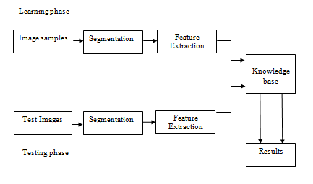 **Figure 3.1:** Architecture of Traffitizer

The Architecture Diagram depicts the overall structure of the software application or model that is to be created or already created architectural diagram. It uses information flow characteristics and maps them into the program structure.

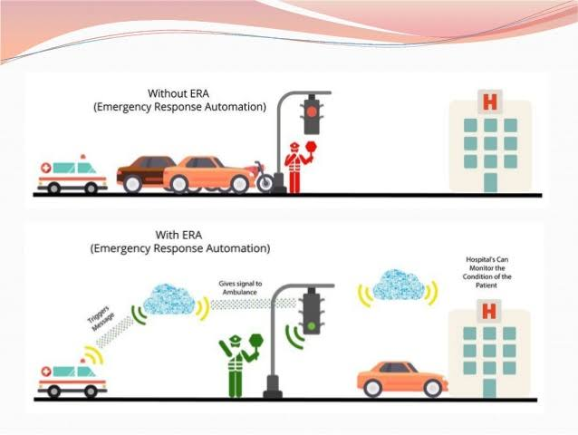

**Figure 3.2:** Working Pictorial Representation of TERS

### 3.2 MODULES:

**3.2.1 TRAFFITIZER Module :-**

It involves two phases learning phase and testing phase.

* **Learning phase:** In this phase, after performing segmentation, features extracted from all the vehicle images along with expected output are stored as reference images.
* **Testing phase:** In this phase, the ambulance models are collected from untrained set of samples and are used to test the developed model for recognition. From the test images, the features are extracted and given to the stored reference images. Then the corresponding output is checked.

**3.3 DESIGN REPRESENTATION:**

The proposed system design models are created using UML tool. UML stands for Unified Modeling Language. UML is a standardized general-purpose modeling language in the field of object-oriented software engineering. The standard is managed, and was created by, the Object Management Group.

UML consist an integrated set of diagrams, developed to help system and software developers for specifying, visualizing, constructing, and documenting the artifacts of software systems, as well as for business modeling and other non-software systems.

Unified Modeling Language is a standardized modeling language consisting of an integrated set of diagrams, developed to help system and software developers for specifying, visualizing, constructing, and documenting the artifacts of software systems, as well as for business modeling and other non-software systems. The UML represents a collection of best engineering practices that have proven successful in the modeling of large and complex systems. The UML is a very important part of developing objects-oriented software and the software development process. The UML uses mostly graphical notations to express the design of software projects. Using the UML helps project teams communicate, explore potential designs, and validate the architectural design of the software. In this article we will give you detailed ideas about what is UML, the history of UML and a description of each UML diagram type, along with UML examples.

The goal of UML is to provide a standard notation that can be used by all object-oriented methods and to select and integrate the best elements of precursor notations. UML has been designed for a broad range of applications. Hence, it provides constructs for a broad range of systems and activities (e.g., distributed systems, analysis, system design and deployment).

* **StarUML**

StarUML is a [UML tool](https://en.wikipedia.org/wiki/UML_tool) by MKLab.StarUML™ is a software modeling platform that supports UML (Unified Modeling Language). It is based on UML version 1.4 and provides eleven different types of diagram, and it accepts UML 2.0 notation.

StarUML 2.0 uses its own file format, with the .uml extension.

StarUML supports 11 UML diagram types. The user can freely create and manage different diagrams as needed.

|  |
| --- |
| 1. Class Diagram |
| 1. Use Case Diagram |
| 1. Sequence Diagram |
| 1. Sequence Diagram (Role) |
| 1. Collaboration Diagram |
| 1. Collaboration Diagram (Role ) |
| 1. Statechart Diagram |
| 1. Activity Diagram |
| 1. Component Diagram |
| 1. Deployment Diagram |
| 1. Composite Structure Diagram |

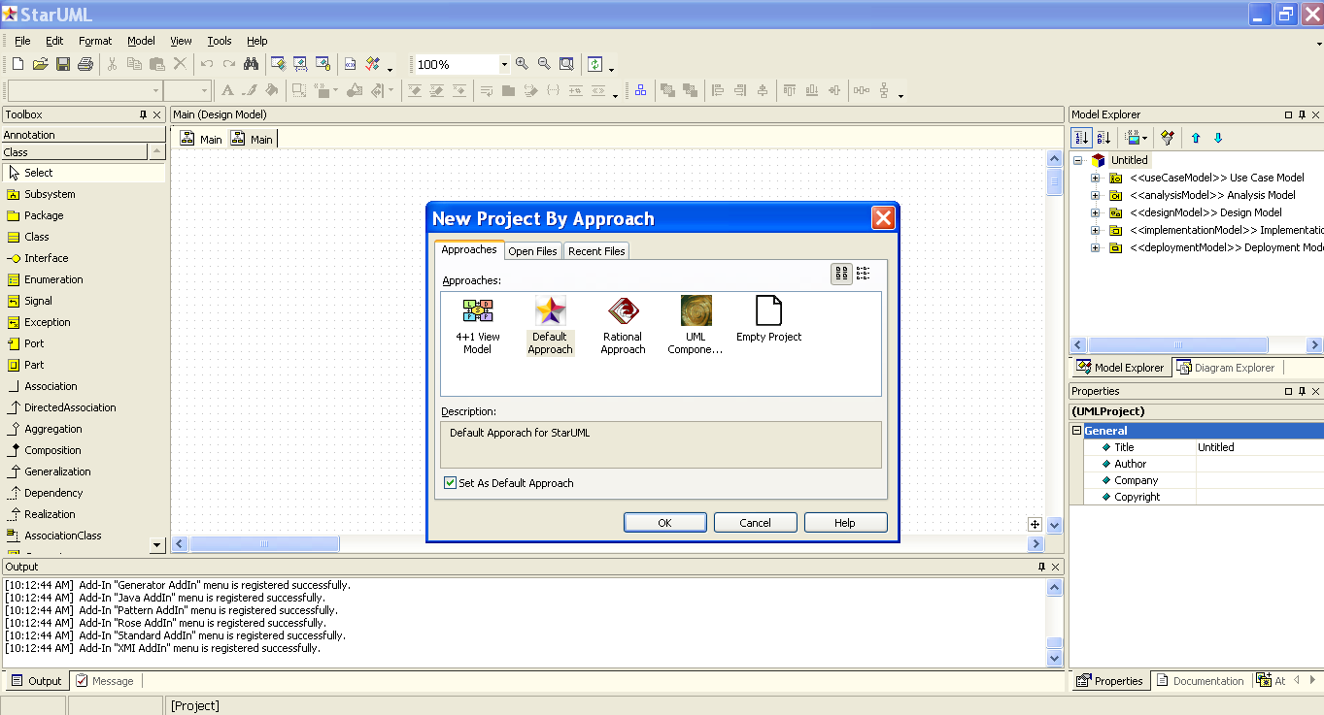

**Figure 3.3:** StarUML Interface

**3.3.1 Use Case diagram :-**

A use case is a set of scenarios that describing an interaction between a user and a system. A use case diagram displays the relationship among actors and use cases. The two main components of a use case diagram are use cases and actors. The use case diagram for the Traffitizer.

The use case diagram has one actor namely ‘Detecting System’ that is used to

* Receive images from camera
* Detect arrival of ambulance
* Check status of signals
* Send data to signal system
* Update signals
* Reset signals

This use case diagram can be used in the initial development and can be extended to include all the needed details.

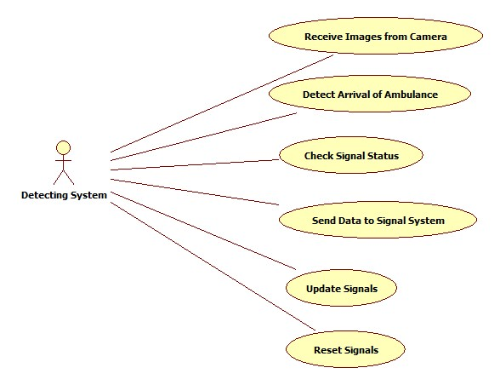

**Figure 3.4:** Use Case diagram

**3.3.2 Flow Chart :-**

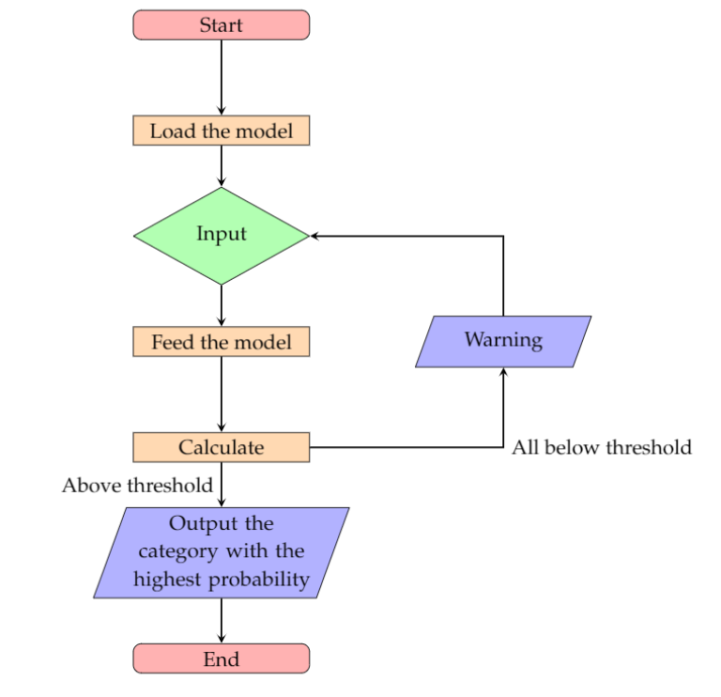

**Figure 3.5:** Flow chart

**3.3.3 Sequence Diagram:**

Sequence diagrams demonstrate the behavior of objects in a use case by describing the objects and the messages they pass. The diagrams are read left to right. This shows that the Camera object clicks images and sends the image data to the Detecting System. The Detecting System object initially sets the signals to default and checks for the presence of ambulance. It updates the data to the Signal System object.   
It changes the signals if required and resets the signals.

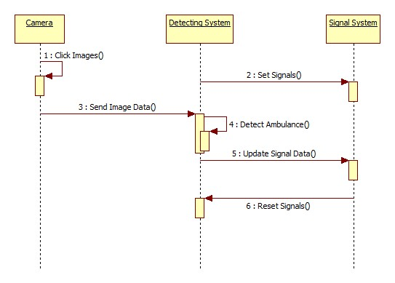

**Figure 3.6:** Sequence diagram

Chapter-IV

**IMPLEMENTATION**

**4.1 TECHNOLOGIES:**

In an Information Technology context, software or hardware implementation encompasses all the post-sale processes which involves environment, analyzing requirements, installation, configuration, customization, running, testing, system integrations.

**4.1.1 HARDWARE:**

1. LED’s
2. Arduino
3. Breadboard
4. **LED's:**

A **light-emitting diode** (**LED**) is a semiconductor light source that emits light when current flows through it. Electrons in the semiconductor recombine with electron holes, releasing energy in the form of photons. The color of the light (corresponding to the energy of the photons) is determined by the energy required for electrons to cross the band gap of the semiconductor.

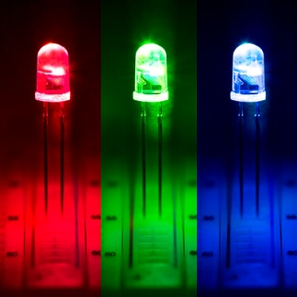

**Figure 4.1:** LEDs (Light Emitting Diodes)

Two types of LED’s are used here. They are:

**Green LED:**

Green signal indicates the vehicles in the traffic to move. So, though an ambulance is struck in the traffic, green signal avoids the traffic and provides a path to an ambulance to reach its destination.

**Red LED:**

Red signal indicates the vehicles to stop. This is used to alert vehicles in the other lanes to stop. This provides a clear path to the ambulance thus avoiding traffic collisions.

1. **Arduino:**

Arduino is an open-source hardware and software company, project and user community that designs and manufactures single-board micro controllers and micro controller kits for building digital devices. Its products are licensed under the GNU Lesser General Public License (LGPL) or the GNU General Public License (GPL), permitting the manufacture of Arduino boards and software distribution by anyone. Arduino boards are available commercially in preassembled form or as do-it-yourself (DIY) kits.

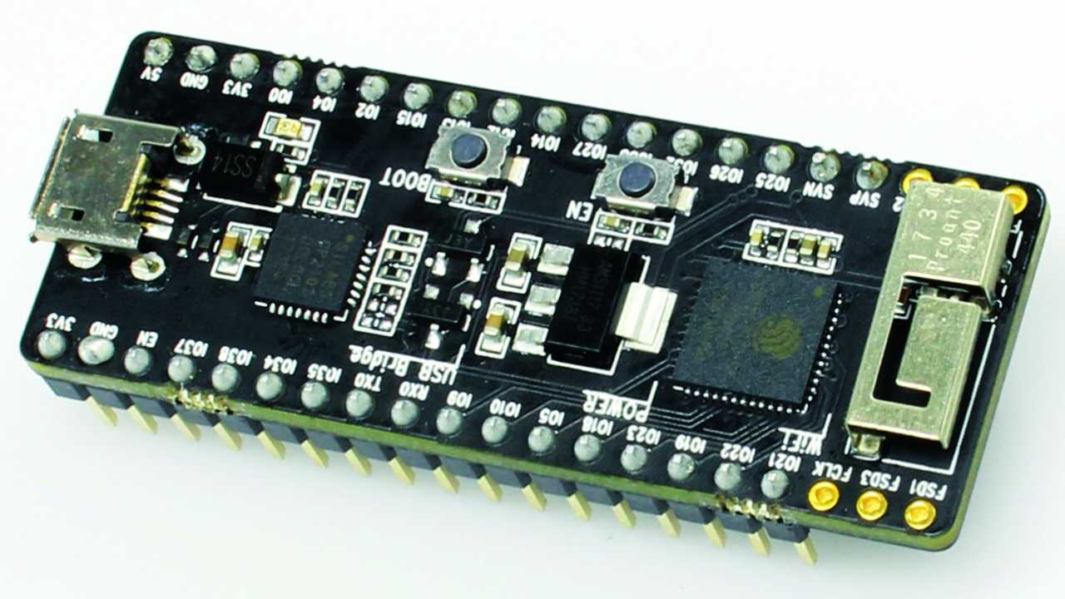

**Figure 4.2:** Arduino

1. **Breadboard:**

A Breadboard is a solder less device for temporary prototype with electronics and test circuit designs. Most electronic components in electronic circuits can be interconnected by inserting their leads or terminals into the holes and then making connections through wires where appropriate. The breadboard has strips of metal underneath the board and connects the holes on the top of the board. The metal strips are laid out as shown below. Note that the top and bottom rows of holes are connected horizontally and split in the middle while the remaining holes are connected vertically.

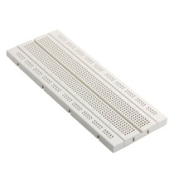

**Figure 4.3:** Bread board

### 4.1.2 SOFTWARE:

#### Cascade GUI Trainer:

Cascade Trainer GUI is an application that can be used to create, train, test and improve cascade classifier models. It uses a graphical interface to set the parameters and make it easy to use OpenCV tools for training and testing classifiers.

Currently Cascade Trainer GUI can be used on Windows (7 or above). The installation procedure is pretty straight forward and it only involves pressing a couple of “Next” buttons.

To train classifiers usually, the utility needs to be provided with thousands of positive and negative image samples, but there are cases when you can achieve the same with less samples.

To start the training, a folder needs to be created for required classifier. Two folders are created inside it. One should be “p” (for positive images) and the other should be “n” (for negative images).

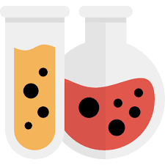

**Figure 4.4:** Cascade-Trainer-GUI Logo

#### Positive image samples:

Positive image samples are the images of the object that needs to be trained with the classifier and detect.

#### Negative image samples:

Negative images are anything except the object images. Negative images must never include any positive images. Negative images can be any image that is not the positive image but in practice, negative images should be relevant to the positive images.

#### Arduino IDE:

The Arduino integrated development environment (IDE) is a cross Platform application (for Windows, macOS, Linux) that is written in the programming language Java. It is used to write and upload programs to Arduino compatible boards, but also, with the help of third-party cores, other vendor development boards.

The source code for the IDE is released under the GNU General Public License. The Arduino IDE supports the languages C and C++ using special rules of code structuring. The Arduino IDE supplies a software library from the Wiring project, which provides many common input and output procedures. User-written code only requires two basic functions, for starting the sketch and the main program loop, that are compiled and linked with a program stub main() into an executable cyclic executive program with the GNU toolchain, also included with the IDE distribution. The Arduino IDE employs the program argued to convert the executable code into a text file in hexadecimal encoding that is loaded into the Arduino board by a loader program in the board's firmware.

**III. PYTHON:**

Python is an interpreted, object-oriented, high-level programming language with dynamic semantics. Its high-level built in data structures, combined with dynamic typing and dynamic binding, make it very attractive for Rapid Application Development, as well as for use as a scripting or glue language to connect existing components together. Python's simple, easy to learn syntax emphasizes readability and therefore reduces the cost of program maintenance. Python supports modules and packages, which encourages program modularity and code reuse. The Python interpreter and the extensive standard library are available in source or binary form without charge for all major platforms, and can be freely distributed.

Often, programmers fall in love with Python because of the increased productivity it provides. Since there is no compilation step, the edit-test-debug cycle is incredibly fast. Debugging Python programs is easy: a bug or bad input will never cause a segmentation fault. Instead, when the interpreter discovers an error, it raises an exception. When the program doesn't catch the exception, the interpreter prints a stack trace. A source level debugger allows inspection of local and global variables, evaluation of arbitrary expressions, setting breakpoints, stepping through the code a line at a time, and so on. The debugger is written in Python itself, testifying to Python's introspective power. On the other hand, often the quickest way to debug a program is to add a few print statements to the source: the fast edit-test-debug cycle makes this simple approach very effective.

**IV PYCHARM:**

JetBrains has developed PyCharm as a cross-platform IDE for Python. In addition to supporting versions 2.x and 3.x of Python, PyCharm is also compatible with Windows, Linux, and macOS. At the same time, the tools and features provided by PyCharm help programmers to write a variety of software applications in Python quickly and efficiently. The developers can even customize the PyCharm UI according to their specific needs and preferences. Also, they can extend the IDE by choosing from over 50 plug-ins to meet complex project requirements.

**Overview of Important Features and Tools Provided by PyCharm**

**Code Editor**

The intelligent code editor provided by PyCharm enables programmers to write high quality Python code. The editor enables programmers to read code easily through colour schemes, insert indents on new lines automatically, pick the appropriate coding style, and avail context-aware code completion suggestions. At the same time, the programmers can also use the editor to expand a code block to an expression or logical block, avail code snippets, format the code base, identify errors and misspellings, detect duplicate code, and auto-generate code. Also, the editor makes it easier for developers to analyse the code and identify the errors while writing code.

**Code Navigation**

The smart code navigation options provided by PyCharm help programmers to edit and improve code without putting extra time and effort. The IDE makes it easier for programmers to go to a class, file and symbols, along with the go to declarations invoked from a reference. The user can even find an item in the source code, code snippet, UI element, or user action almost immediately. They can further locate usage of various symbols, and set bookmarks in the code. At the same time, the developers can even take advantage of the code navigation feature to scrutinize the code thoroughly in the lens mode.

**Refactoring**

PyCharm makes it easier for developers to implement both local and global changes quickly and efficiently. The developers can even take advantage of the refactoring options provided by the IDE while writing plain Python code and working with Python frameworks. They can avail the rename and move refactoring for files, classes, functions, methods, properties, parameters, and local/global variables. Likewise, they can improve code quality by extracting variables, fields, constants, and parameters. Also, PyCharm allows programmers to break up longer classes and methods through extract method.

**Support for Popular Web Technologies**

PyCharm makes it easier for programmers to write various web applications in Python supporting widely used web technologies like HTML, CSS, JavaScript, TypeScript and CoffeeScript. The web developers can use the live editing preview option provided by the IDE to view a single web page simultaneously in the editor and browser. At the same time, the live edit feature provided by the IDE enables programmers to see the changes made to the code instantaneously on a web browser. PyCharm further allows developers to avail a JavaScript debugger as well as CoffeeScript and TypeScript editors. It even simplifies isomorphic web application development by supporting both AngularJS and NodeJS.

**Support for Popular Python Web Frameworks**

In addition to supporting commonly used web technologies, PyCharm also provides first-class support for a robust Python web framework like Django. The developers can use the IDE to avail code completion suggestions for Django tags, filters, parameters, and template variables. Also, they can gather additional information about tags and filters by referring to the quick documentation. The Python IDE even helps web developers to debug Django templates, format the code, verify the code, and manage .py consoles. At the same time, PyCharm also supports widely used Python web frameworks like Pyramid and Web2Py. It provides code completion and navigation options specific to Pyramid. Likewise, it allows web developers to avail code completion and navigation options while working with Web2Py.

**Support for Python Scientific Libraries**

PyCharm further helps programmers to use Python more efficiently in big data and data science projects. It supports some of the widely used scientific libraries for Python — NumPy, Anaconda and Metplotlib. The developers can work efficiently with these scientific libraries by availing the interactive graphs, deep code insight, and array viewers provided by the IDE. They can even run the REPL Python console provided by PyCharm to avail robust features like on-the-fly syntax check and code inspection. At the same time, the programmers can also integrate the IDE seamlessly with IPython Notebook to create innovative solutions without putting extra time and effort.

**Database Tools**

In addition to supporting various Python libraries and frameworks, PyCharm allows developers to work with a number of relational databases including Oracle, SQL Server, MySQL and PostgreSQL. The developers can further use the IDE to run queries, edit SQL code, browse data, alter table data, and alter/analyze schemas. PyCharm further supports SQLAlchemy library and inject SQL code into code written in various programming languages. The professional edition of the IDE further makes it easier for developers to handle large volumes of data efficiently through data grids.

**Visual Debugger**

The visual debugger provided by the IDE helps programmers to debug Python, JavaScript, and Django code. The developers can use the inline debugger to see live debugging data directly on the editor. Likewise, they can debug multiple Python processes simultaneously and step through the code bypassing libraries. PyCharm further creates reusable and customizable configuration for each test script or debugger execution. The users even have option to facilitate remote debugging by integrating the visual debugger with remote interpreters.

**Built-in Terminal**

PyCharm comes with local terminals for Windows, Linux, and macOS. The built-in terminal enables programmers to continue coding and testing without leaving the IDE. Also, the programmers can use the IDE to run Python files and configure custom Python environments according to precise project requirements. At the same time, they can run interactive Python or Django consoled directly in the IDE. The console provides useful features like code completion, automatic braces matching, and dynamic syntax change. The programmers even have option to integrate the console with both local and remote interpreters.

**Support for Major Version Control Systems**

PyCharm allows developers to work with widely used version control systems like Git, Mercurial, Perforce and SVN. It even performs complex tasks like adding, removing, and deleting files automatically. The developers even have option to avail a number of features provided by the IDE regardless of their choice of version control system — grouping individual changes into multiple change lists, setting aside the changes to be restored, monitor changes made to the code repository by various users, and check the changes made to the code before being integrated into the local copy.

**Software Testing**

Like other IDEs, PyCharm also comes with features and tools to simplify Python application testing. It allows developers to perform unit testing through popular Python testing frameworks like Nose, Attest and Doctests. The testers even have option to run individual or multiple test files and test classes. They can further integrate the IDE with Coverage.py to measure code coverage while testing the applications. While testing multi-threaded applications, the testers can use the thread concurrency visualization option provided by the IDE to control the application fully and efficiently. At the same time, PyCharm enables users to deliver high quality software by implementing behaviour-driven development (BDD).

### 5.1.3 PACKAGES USED IN PYTHON:

* **OpenCV package:**

Open CV is an open source C++ library for image processing and computer vision originally developed by Intel and now supported by Willow Garage. It is free for both commercial and non-commercial use. Therefore, it is not mandatory for your Open CV communication to open for free it is a library of many inbuilt functions mainly aimed at real time image processing. Now it has several hundreds of image processing and computer vision algorithms which make developing advanced computer vision applications easy and efficient if you are having any troubles with installing Open CV or configure your Visual Studio IDE for Open CV, please refer to Installing and Configuring with Visual Studio.

**OpenCV is Open Source Commuter Vision Library** which has C++, Python and Java interfaces and supports Windows, Linux, Mac OS, iOS and Android. So, it can be easily installed in Raspberry Pi with Python and Linux environment. And Raspberry Pi with OpenCVand attached camera can be used to create many real-time image processing applications like Face detection, face lock, object tracking, [car number plate detection](https://circuitdigest.com/tutorial/vehicle-number-plate-detection-using-matlab-and-image-processing), [Home security system](https://circuitdigest.com/microcontroller-projects/raspberry-pi-iot-intruder-alert-system) etc.

**Object detection and recognition** form the most important use case for computer vision, they are used to do powerful things such as

* Labelling scenes
* Robot Navigation
* Self-driving cars
* Body recognition (Microsoft Kinect)
* Disease and cancer detection
* Facial recognition
* Handwriting recognition
* Identifying objects in satellite images

**Object Detection VS Recognition:**

Object recognition is the second level of object detection in which computer is able to recognize an object from multiple objects in an image and may be able to identify it. Now, we will perform some image processing functions to find an object from an image.

In input the gray-scale image to find the object and template. Then apply the template matching method for finding the objects from the image.

The whole function returns an array which is inputted in result, which is the result of the template matching procedure.

And which gives the coordinates or the bounding box where the object was found in an image, and when we get those coordinates draw a rectangle over it, and stretch a little dimension of the box so the object can easily fit inside the rectangle.

There are variety of methods to perform template matching and in this case stands for correlation coefficient takes a “sliding window” of the object and slides it over the image from left to right and top to bottom, one pixel at a time. Then for each location, we compute the correlation coefficient to determine how “good” or “bad” the match is.

Regions with sufficiently high correlation can be considered as matches, from there all we need is to call to find where the good matches are in template matching.

### **Feature Description Theory:**

In template matching we slide a template image across a source image until a match is found. But it is not the best method for object recognition, as it has severe limitations. This method isn’t very resilient.

The following factors make template matching a bad choice for object detection.

* Rotation renders this method ineffective.
* Size (known as scaling) affects this as well.
* Photometric changes (e.g. brightness, contrast, hue etc.)
* Distortion form view point changes (Affine).
* The one solution for this problem is **image features**

**Image features**are interesting areas of an image that are somewhat unique to that specific image. They are also called **key point features** or **interest points**.

The sky is an uninteresting feature, whereas as certain key points (marked in red circles) can be used for the detection of the above image (interesting Features). The image shown above clearly shows the difference between the interesting feature and uninteresting feature.

**Importance of feature detection:**

Features are important as they can be used to analyze, describe and match images. They have extensive use in:

* Image alignment – e.g. panorama stitching (finding corresponding matches so we can stitch images together)
* 3D reconstruction
* Robot navigation
* Object recognition
* Motion tracking
* And more!

Interesting areas carry a lot of distinct information and unique information of an area. Typically, they are areas of high change of intensity, corners or edges and more. But always be careful as noise can appear “informative” when it is not! So, try to blur so as to reduce noise.

**Key Features:**

1. Optimized for real time image processing & computer vision applications.
2. Primary interface of Open CV is in C++.
3. There are also C, Python and JAVA full interfaces.
4. Open CV applications run on Windows, Android, Linux, Mac and iOS
5. Optimized for Intel processors

* **NumPy Package:**

NumPy is a Python package which stands for ‘Numerical Python’. It is the core library for scientific computing, which contains a powerful n-dimensional array object, provide tools for integrating C, C++ etc. It is also useful in linear algebra, random number capability etc. NumPy array can also be used as an efficient multi-dimensional container for generic data.

NumPy or Numerical Python is linear algebra developed in Python. Why do a large number of developers and experts prefer it to the other Python libraries for machine learning! Almost all Python machine-learning packages like Mat-plotlib, SciPy, Scikit-learn, etc. rely on this library to a reasonable extent. It comes with functions for dealing with complex mathematical operations like linear algebra, Fourier transformation, random number and features that work with matrices and n-arrays in Python. NumPy Python package also performs scientific computations. It is widely used in handling sound waves. NumPy is the fundamental package for scientific computing with Python. It contains among other things:

* a powerful N-dimensional array object
* sophisticated (broadcasting) functions
* tools for integrating C/C++ and Fortran code
* useful linear algebra, Fourier transform, and random number capabilities

Besides its obvious scientific uses, NumPy can also be used as an efficient multi-dimensional container of generic data. Arbitrary data-types can be defined. This allows NumPy to seamlessly and speedily integrate with a wide variety of databases.

NumPy is licensed under the [BSD license](https://numpy.org/license.html#license), enabling reuse with few restrictions. NumPy targets the [CPython](https://en.wikipedia.org/wiki/CPython) reference [implementation](https://en.wikipedia.org/wiki/Programming_language_implementation) of Python, which is a non-optimizing [bytecode](https://en.wikipedia.org/wiki/Bytecode) interpreter. Mathematical algorithms written for this version of Python often run much slower than [compiled](https://en.wikipedia.org/wiki/Compiler) equivalents. NumPy addresses the slowness problem partly by providing multidimensional arrays and functions and operators that operate efficiently on arrays, requiring rewriting some code, mostly inner loops using NumPy.

Using NumPy in Python gives functionality comparable to [MATLAB](https://en.wikipedia.org/wiki/MATLAB) since they are both interpreted, and they both allow the user to write fast programs as long as most operations work on arrays or matrices instead of [scalars](https://en.wikipedia.org/wiki/Scalar_(computing)). In comparison, MATLAB boasts a large number of additional toolboxes, notably [Simulink](https://en.wikipedia.org/wiki/Simulink), whereas NumPy is intrinsically integrated with Python, a more modern and complete programming language. Moreover, complementary Python packages are available; [SciPy](https://en.wikipedia.org/wiki/SciPy) is a library that adds more MATLAB-like functionality and [Matplotlib](https://en.wikipedia.org/wiki/Matplotlib) is a plotting package that provides MATLAB-like plotting functionality. Internally, both MATLAB and NumPy rely on [BLAS](https://en.wikipedia.org/wiki/Basic_Linear_Algebra_Subprograms) and [LAPACK](https://en.wikipedia.org/wiki/LAPACK) for efficient linear algebra computations.

Python [bindings](https://en.wikipedia.org/wiki/Language_binding) of the widely used [computer vision](https://en.wikipedia.org/wiki/Computer_vision) library [OpenCV](https://en.wikipedia.org/wiki/OpenCV) utilize NumPy arrays to store and operate on data. Since images with multiple channels are simply represented as three-dimensional arrays, indexing, [slicing](https://en.wikipedia.org/wiki/Array_slicing#1991:_Python) or [masking](https://en.wikipedia.org/wiki/Mask_(computing)#Image_masks) with other arrays are very efficient ways to access specific pixels of an image. The NumPy array as universal data structure in OpenCV for images, extracted [feature points](https://en.wikipedia.org/wiki/Interest_point_detection), [filter kernels](https://en.wikipedia.org/wiki/Kernel_(image_processing)) and many more vastly simplifies the programming workflow and [debugging](https://en.wikipedia.org/wiki/Debugger).

**4.2 SAMPLE CODE:**

**4.2.1 amb_det_video.py:**

import cv2

import serial #for Serial communication

import time #for delay functions

arduino = serial.Serial('COM3',9600) #Create Serial port object called arduinoSerialData

video_src = 'amb_present.mp4'

ambulance_cap= cv2.VideoCapture(video_src)

ambulance_cascade = cv2.CascadeClassifier('cascade.xml')

print("started")

time.sleep(1)

while True:

ret, img = ambulance_cap.read()

if (type(img) == type(None)):

break

c=0

yellow = cv2.cvtColor(img, cv2.COLOR_BGR2GRAY)

ambulances = ambulance_cascade.detectMultiScale(yellow, 1.1, 2)

for (x,y,w,h) in ambulances:

cv2.rectangle(img,(x,y),(x+w,y+h),(0,255,255),2)

if(c==0):

print("Ambulance detected from ",time.strftime("%H:%M:%S",time.localtime()))

c=c+1

arduino.write(b"1")

time.sleep(0.1)

else:

print("No Ambulance at:",time.strftime("%H:%M:%S",time.localtime()))

arduino.write(b"0")

#time.sleep(1)

cv2.imshow('traffitizer', img)

if cv2.waitKey(33) == 27:

break

cv2.destroyAllWindows()

**4.2.2 arduino-traffitizer.ino:**

int data;

int led1=4;

int led2=16;

int led3=5;

void setup()

{

Serial.begin(9600);

pinMode(led1, OUTPUT);

pinMode(led2, OUTPUT);

pinMode(led3,OUTPUT);

digitalWrite (led1,LOW); //GREEN SIGNAL

digitalWrite (led2,LOW);//RED SIGNAL

digitalWrite (led3,LOW);//ORANGE SIGNAL

}

void loop()

{

while(Serial.available())

{

data = Serial.read();

}

if (data == '1')

{

digitalWrite (led3,HIGH);//ORANGE SIGNAL ON

delay(100);

digitalWrite (led3,LOW);//ORANGE SIGNAL OFF*/

digitalWrite (led1, HIGH);// GREEN SIGNAL ON

//digitalWrite(led2,LOW);//RED SIGNAL OFF

delay(1000);

}

else //(data == '0')

{

digitalWrite (led1,LOW);//GREEN SIGNAL OFF

digitalWrite (led2, HIGH);//RED SIGNAL ON

delay(1000);

}

**4.2.3 amb_det_image.py :-**

import cv2

import serial # for Serial communication

import time # for delay functions

arduino = serial.Serial('COM3', 9600)

on=0

time.sleep(1)

now=time.time()

amb_cascade=cv2.CascadeClassifier('cascade.xml')

img=cv2.imread('amb_2.jpg')

yellow = cv2.cvtColor(img,cv2.COLOR_BGR2GRAY)

ambs=amb_cascade.detectMultiScale(yellow,1.01,7)

for(x,y,w,h) in ambs:

img=cv2.rectangle(img,(x,y),(x+w,y+h),(255,0,0),2)

#arduino.write(b"0")

print("Ambulance detected")

on = 1

#cv2.imshow('img',img)

#time.sleep(10)

else:

arduino.write(b"1")

cv2.imshow('img',img)

cv2.waitKey(0)

cv2.destroyAllWindows()

Chapter-V

**TESTING**

**5.1 METHODOLOGIES:**

The purpose of testing is to discover errors. Testing is the process of trying to discover every conceivable fault or weakness in a work product. It is the process of exercising software with the intent of ensuring that the Software system meets its requirements and user expectations and does not fail in an unacceptable manner. There are various types of test. Each test type addresses a specific testing requirement.

**5.1.1 UNIT TESTING:**

Unit testing involves the design of test cases that validate that the internal program logic is functioning properly, and that program inputs produce valid outputs. All decision branches and internal code flow should be validated. It is the testing of individual software units of the application .it is done after the completion of an individual unit before integration. This is a structural testing, that relies on knowledge of its construction and is invasive. Unit tests perform basic tests at component level and test a specific business process, application, and/or system configuration. Unit tests ensure that each unique path of a business process performs accurately to the documented specifications and contains clearly defined inputs and expected results.

**5.1.2 INTEGRATION TESTING:**

Integration tests are designed to test integrated software components to determine if they actually run as one program. Testing is event driven and is more concerned with the basic outcome of screens or fields. Integration tests demonstrate that although the components were individually satisfaction, as shown by successfully unit testing, the combination of components is correct and consistent. Integration testing is specifically aimed at exposing the problems that arise from the combination of components.

**5.1.3 VALIDATION TESTING:**

Functional tests provide systematic demonstrations that functions tested are available as specified by the business and technical requirements, system documentation, and user manuals.

Functional testing is centered on the following items:

Valid Input : identified classes of valid input must be accepted.

Invalid Input : identified classes of invalid input must be rejected.

Functions : identified functions must be exercised.

Output : identified classes of application outputs must be exercised.

Systems/Procedures : interfacing systems or procedures must be invoked.

Organization and preparation of functional tests is focused on requirements, key functions, or special test cases. In addition, systematic coverage pertaining to identify Business process flows; data fields, predefined processes, and successive processes must be considered for testing. Before functional testing is complete, additional tests are identified and the effective value of current tests is determined.

**5.1.4 SYSTEM TESTING:**

System testing ensures that the entire integrated software system meets requirements. It tests a configuration to ensure known and predictable results. An example of system testing is the configuration-oriented system integration test. System testing is based on process descriptions and flows, emphasizing pre-driven process links and integration points.

**5.2 TEST CASES:**

|  |  |  |  |
| --- | --- | --- | --- |
| **Inputs** | **Expected Output** | **Actual Output** | **Result** |
| Traffic without Ambulance | Green Signal from Red | Green Signal from Red | Pass |
| Traffic with Ambulance | Red Signal Stays | Red Signal Stays | Pass |
| Car Queue in the Traffic | Red Signal Stays ERS | Turns to Green | Fail |
| Ambulance Presence | Turns to Green | Red Stays | Fail |

**Table 5.1:** Test CasesChapter-VI

**DEPLOYMENT**

The following are the minimum requirements to deploy and utilize proposed system at end user side:

* **HARDWARE REQUIREMENTS:**

Processor : Intel P4

RAM : 1 GB

Hard disk : 40 GB

Connectivity : Internet

* **SOFTWARE REQUIREMENTS:**

Operating System : Windows 7

Web Browser : Firefox 56/ Chrome 64

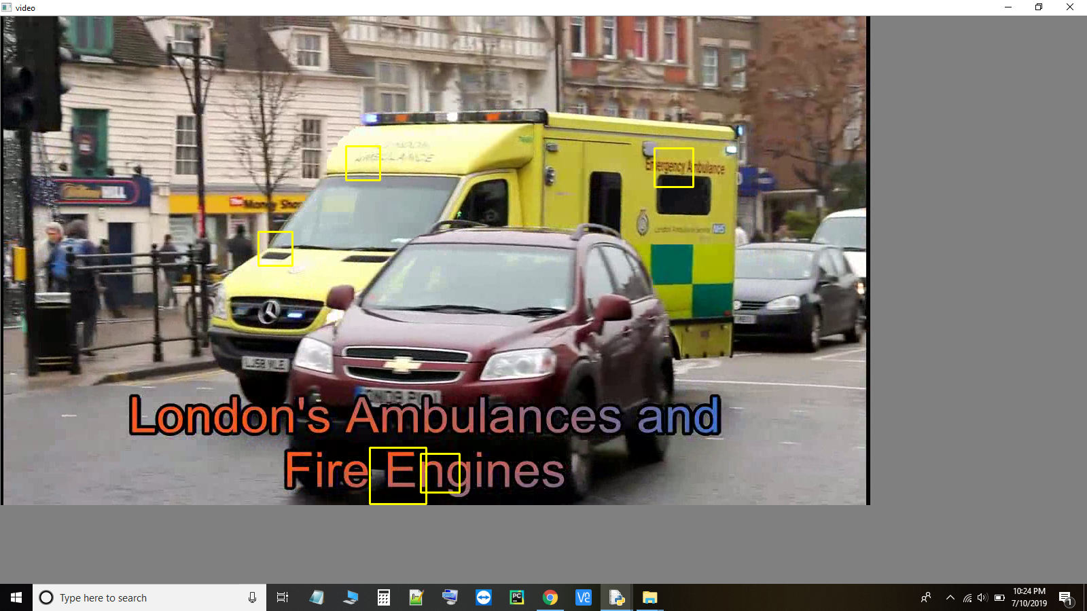

**Figure 6.1:** AMBULANCE text detection

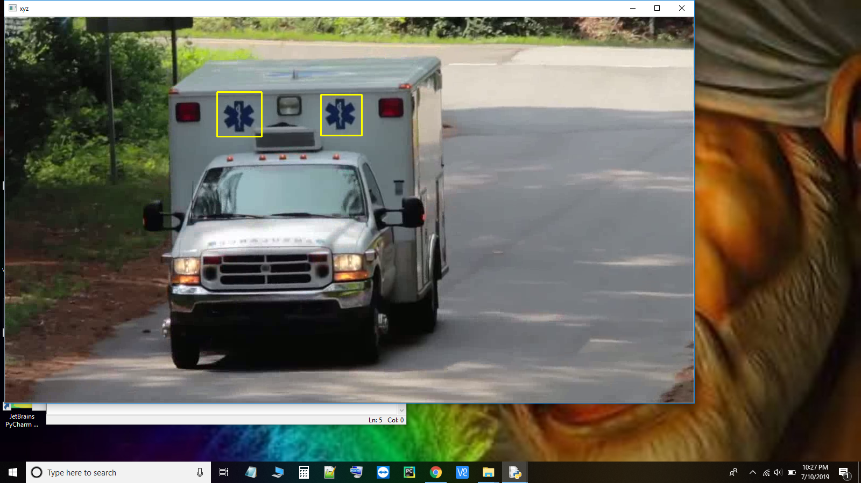

**Figure 6.2:** Ambulance Symbol Detection

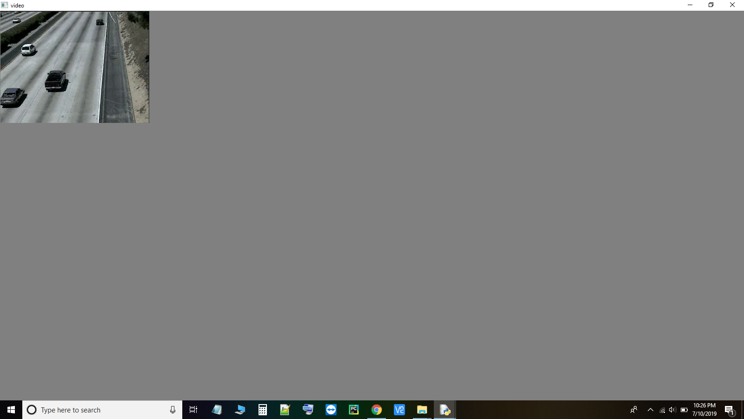**Figure 6.3:** Detection of Absence of Ambulance

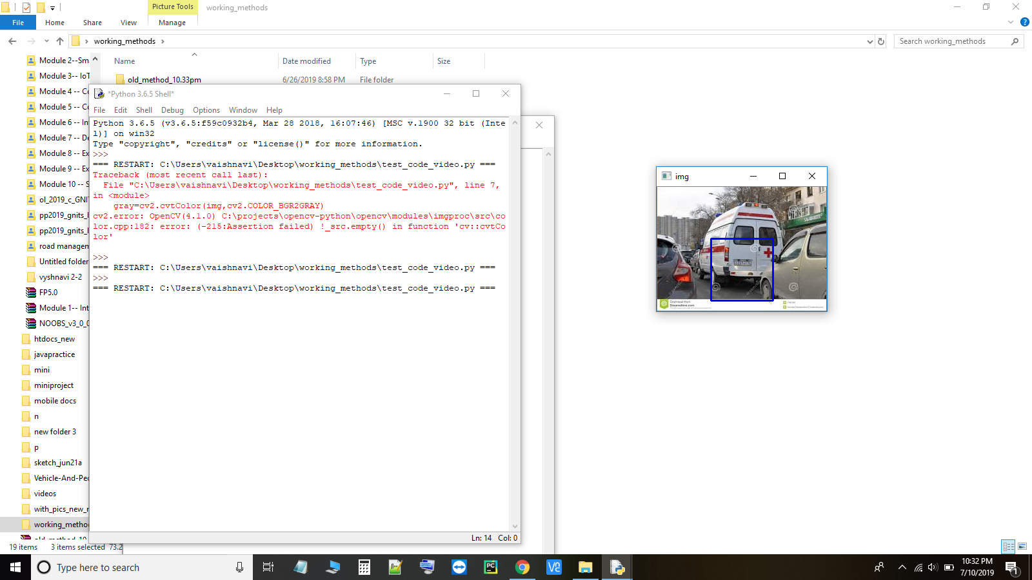

**Figure 6.4:** Detection of PLUS (+) symbol

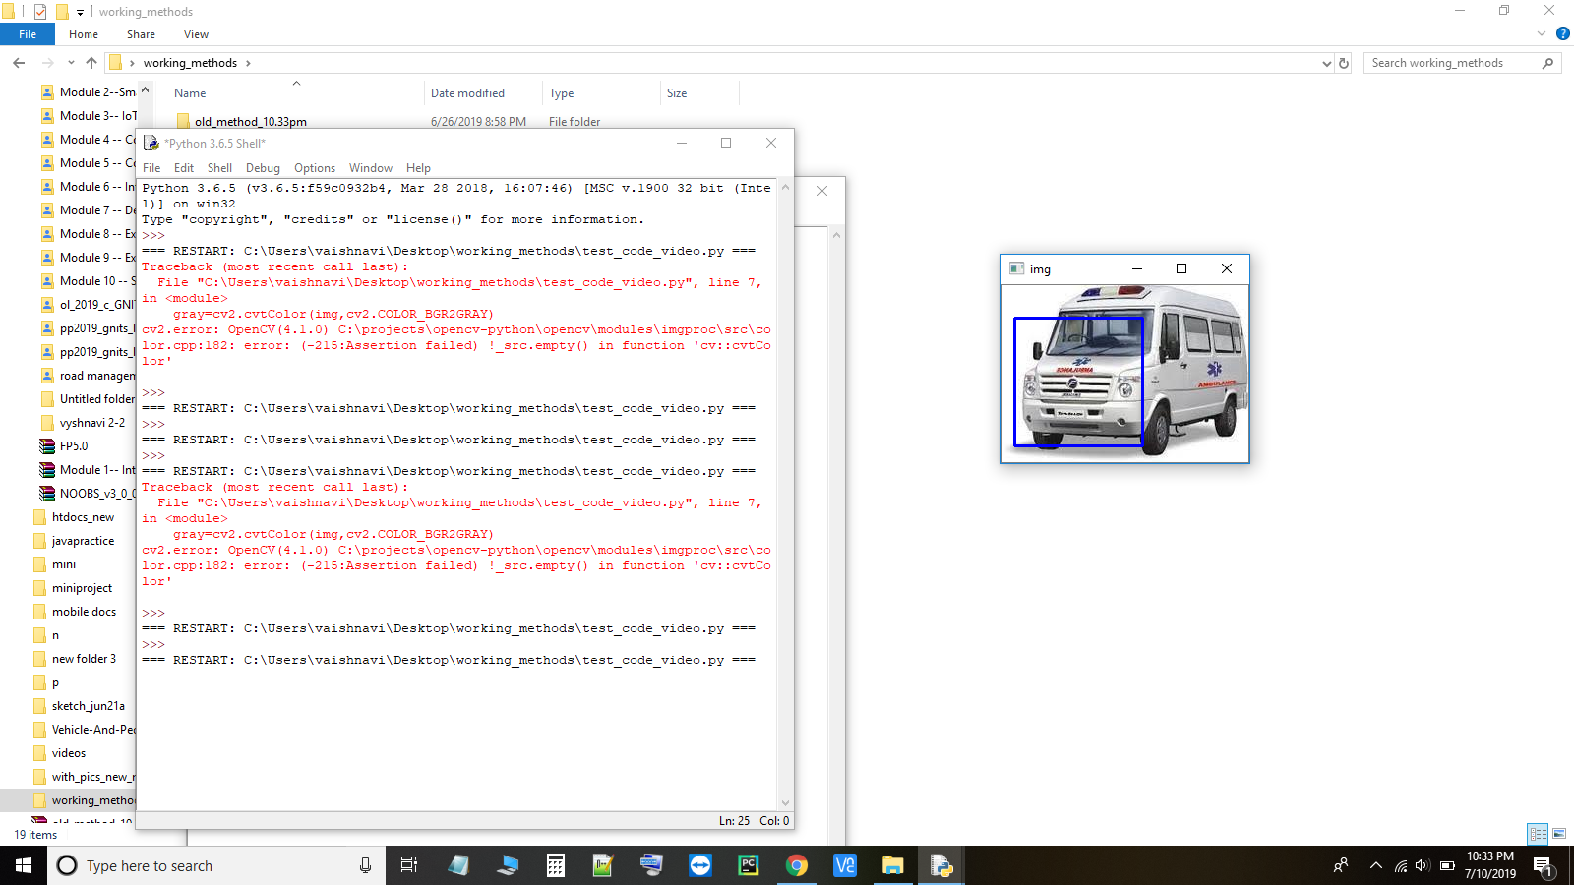

**Figure 6.5:** Detection of Ambulance Symbol and Text

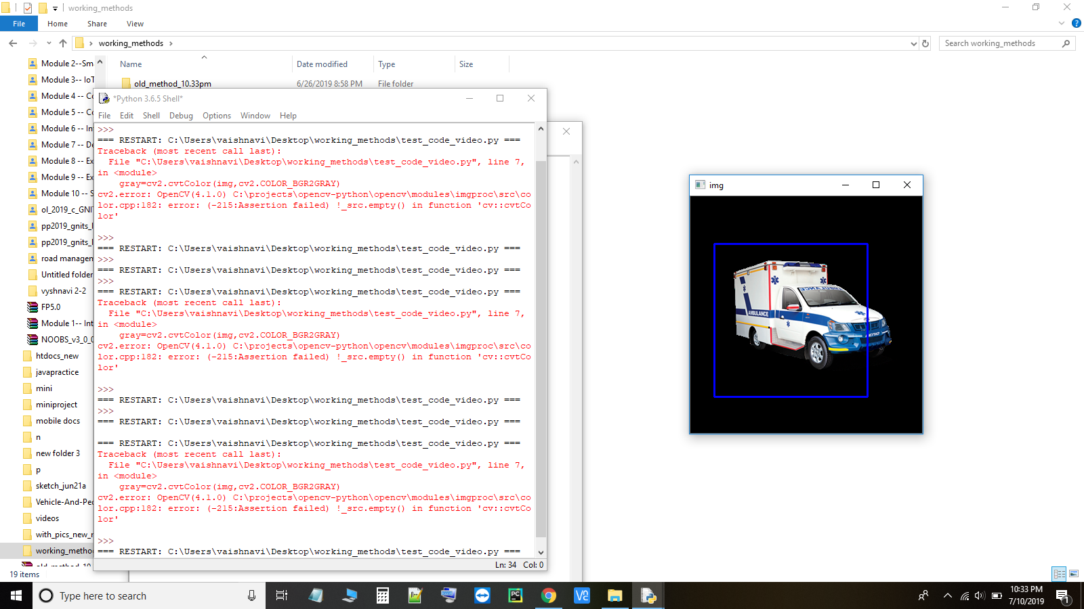

**Figure 6.6:** Detection of Ambulance Vehicle

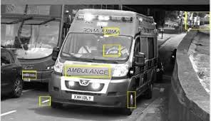

**Figure 6.7:** Ambulance Detection

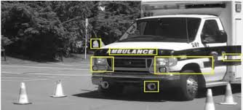

**Figure 6.8:** Ambulance Detected using Signs

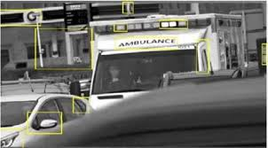

**Figure 6.9:** Analyzing with Surroundings

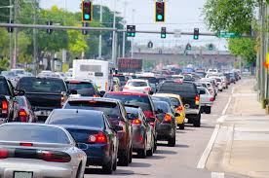

**Figure 6.10:** Traffic Queue at Signal Post

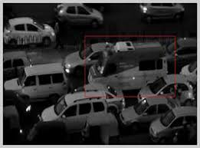

**Figure 6.11:** Traffic Queue during the low light

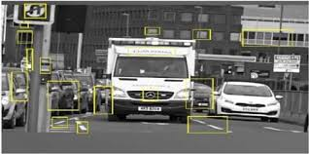

**Figure 6.12:** Scanning the Ambulance

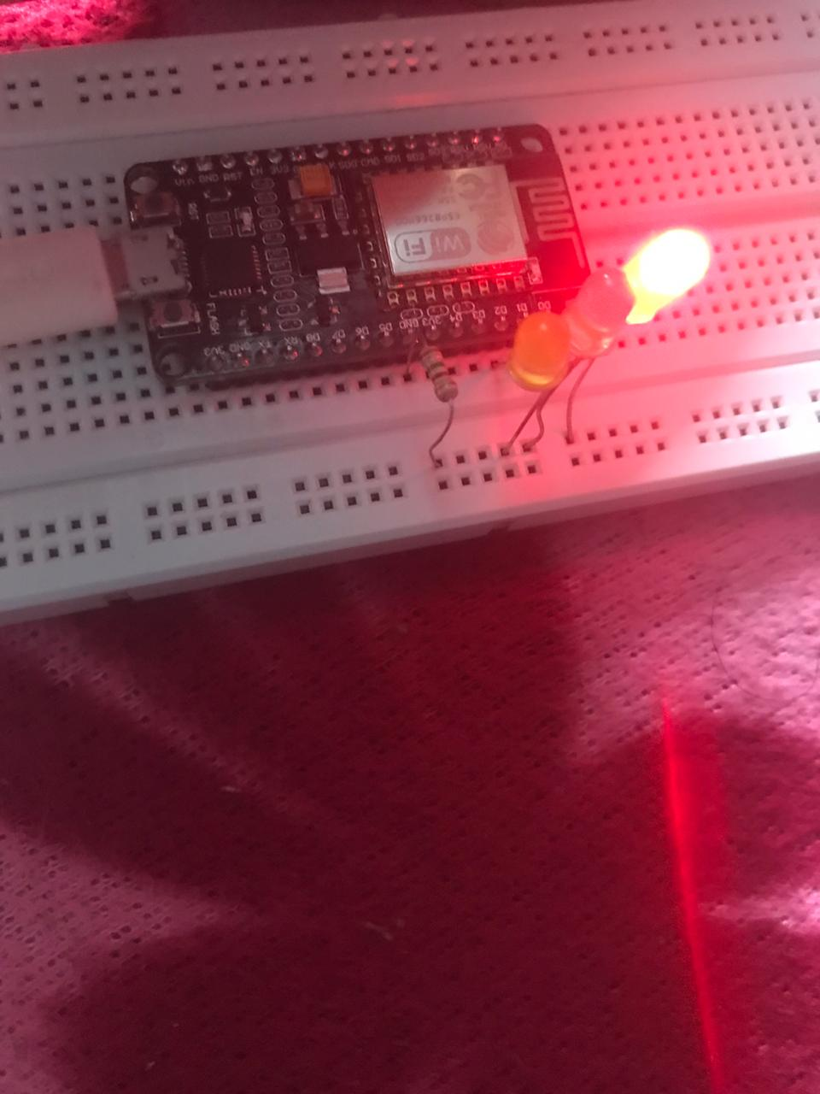

**Figure 6.13:** Traffic Red Light

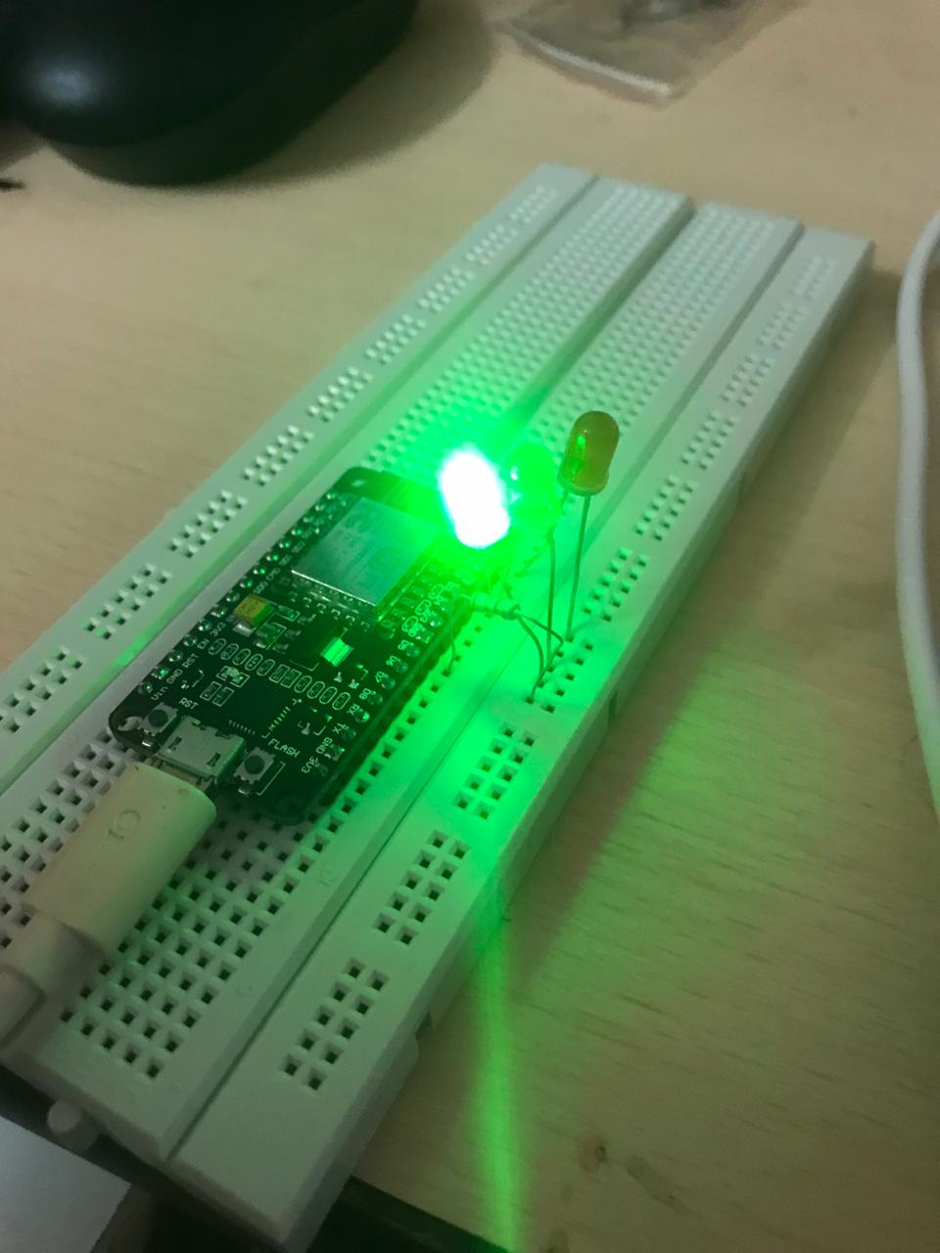

**Figure 6.14:** Traffic Green Light

Chapter-VII

**CONCLUSION**

The proposed system helps to solve the problem of traffic congestion during emergency. The timing of each signal can be automatically adjusted according to the presence of an ambulance clearing the path for the ambulance in emergency cases. It will help patients in taking decisions for reaching their destination in time to avoid wastage of time by an ambulance due to heavy traffic. The automatic changes in traffic signals of a junction can be altered. It is more consistent in detecting ambulance presence because it uses actual traffic images and visualizes the reality, so it functions much better than those systems that rely on the detection of the vehicles metal content. Any type of ambulance can be detected easily by recognizing important criteria like symbol, emergency number, text present on win shield and back window of the ambulance.

Chapter-VIII

**FUTURE ENHANCEMENTS**

It can be further extended in such a way that the signals can be altered based on the density of the vehicles present in a junction. This can reduce traffic congestion as well as help the ambulance to reach the destination in time and can also create an android application which will be used by the ambulance driver. Whenever the driver encounters an emergency case, he can open the app and give the details of the source and destination. The system uses the location of the ambulance and whenever the ambulance moves from one junction to another junction, the respective traffic police will get an alert to clear the path. This can also be helpful for the patients to save their lives.

**BIBLIOGRAPHY**

**PUBLICATIONS:**

1. Ayush Kr. Mittal and Deepika Bhandari., A novel approach to implement Green Wave System and detection of stolen vehicles, Third IEEE International Advance Computing Conference (IACC),2013.
2. Suresh Sharma, A.Pithora, G.Guptha, M.Goel, and M.Sinha published, “A RFID System’’, April,2013.
3. Geetha.E, V.Viswanadha, Kavitha.G proposed ,”An Intelligent Auto Traffic Signal Control system”, July 2014”.

**BOOKS:**

1. Rafael C. Gonzalez and Richard E. Woods., Digital Image Processing, Pearson, Fourth Edition,2017
2. Ravishankar Chityala and Sridevi Pudipeddi., Image Processing and Acquisition using Python,Chapman& Hall/CRC Mathematical and Computational Imaging Sciences Series, First Edition,2014
3. Ashwin Pajankar., Raspberry Pi Image Processing Programming: Develop Real-Life Examples with Python, Pillow, and SciPy, First Edition,2017

**WEBSITES:**

1. <https://www.geeksforgeeks.org/opencv-python-program-vehicle-detection-video-frame>
2. <https://www.pyimagesearch.com/2018/11/12/yolo-object-detection-with-opencv/>
3. <https://www.edureka.co/blog/tensorflow-object-detection-tutorial/>